AI Assisted Coding Lab Assignment (1.4/24)

Name : Aluwala Sharanya

Roll No : 2403A52013

Section : CS-AI B02

# Task 1: GitHub Copilot Setup

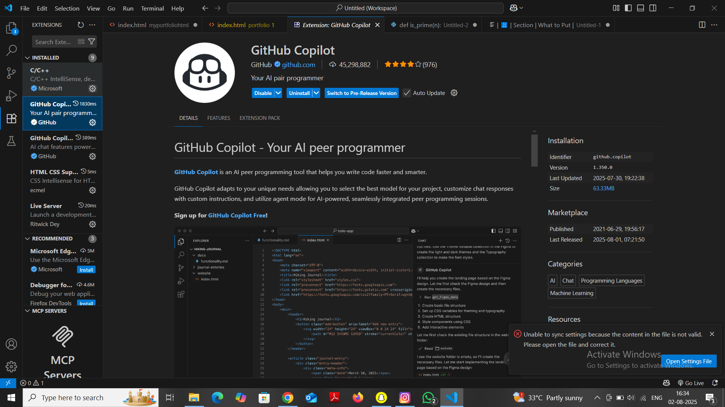

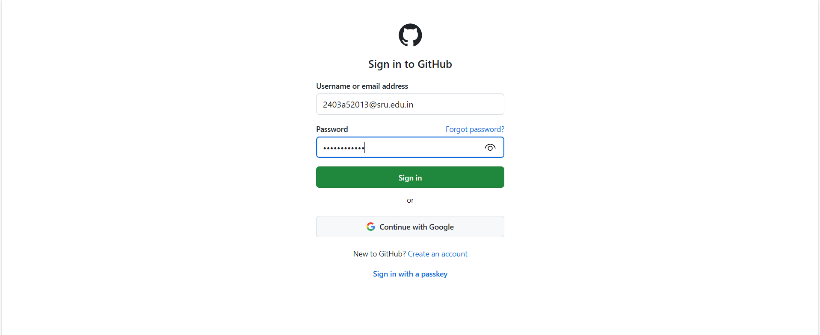

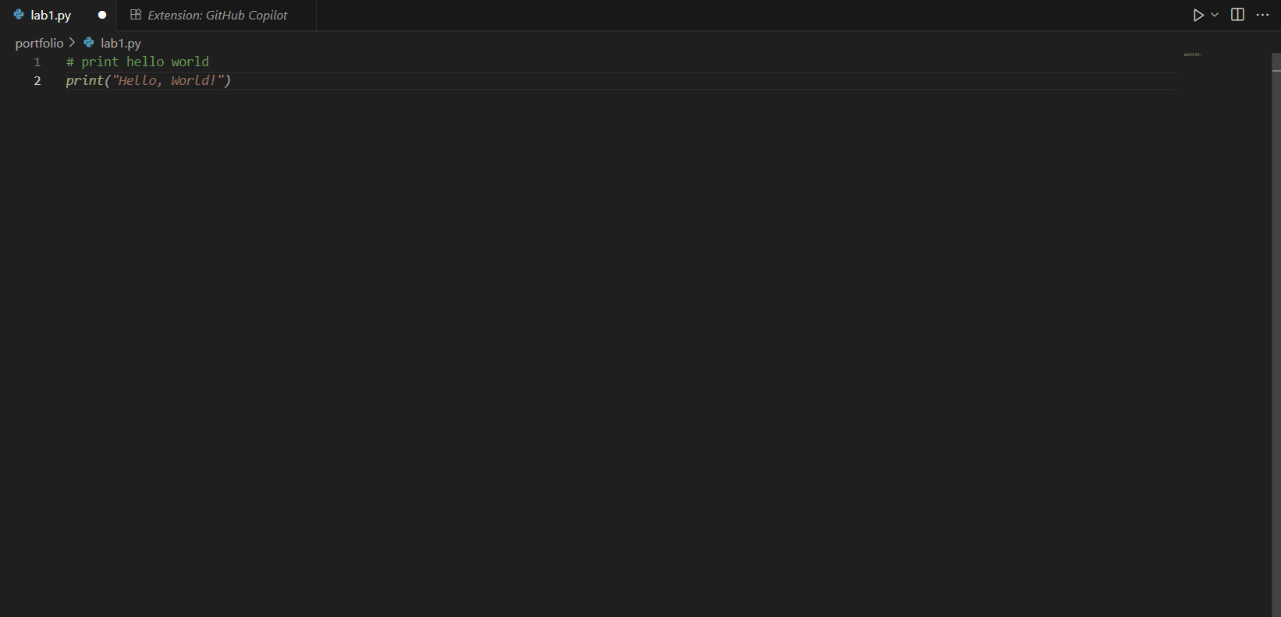

# Task 2: Maximum of Three Numbers

Prompt used:  
# Function to find the maximum of three numbers

Code:

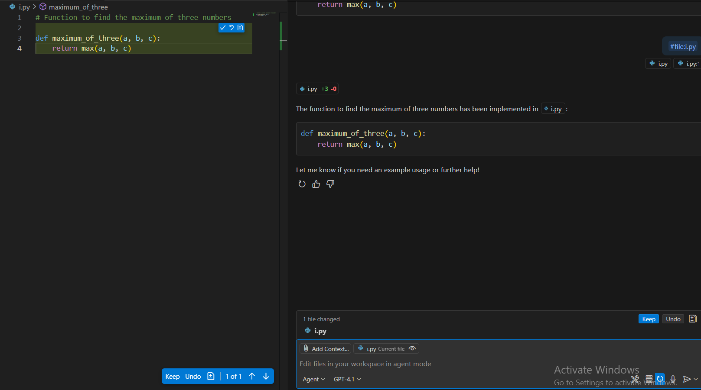

Explanation:  
The function uses Python’s built-in max() function to return the largest of the three inputs.

Sample Output:  
Maximum is: 25

# Task 3: Factorial (Recursive)

Prompt used:  
# Recursive function to calculate factorial

Code:

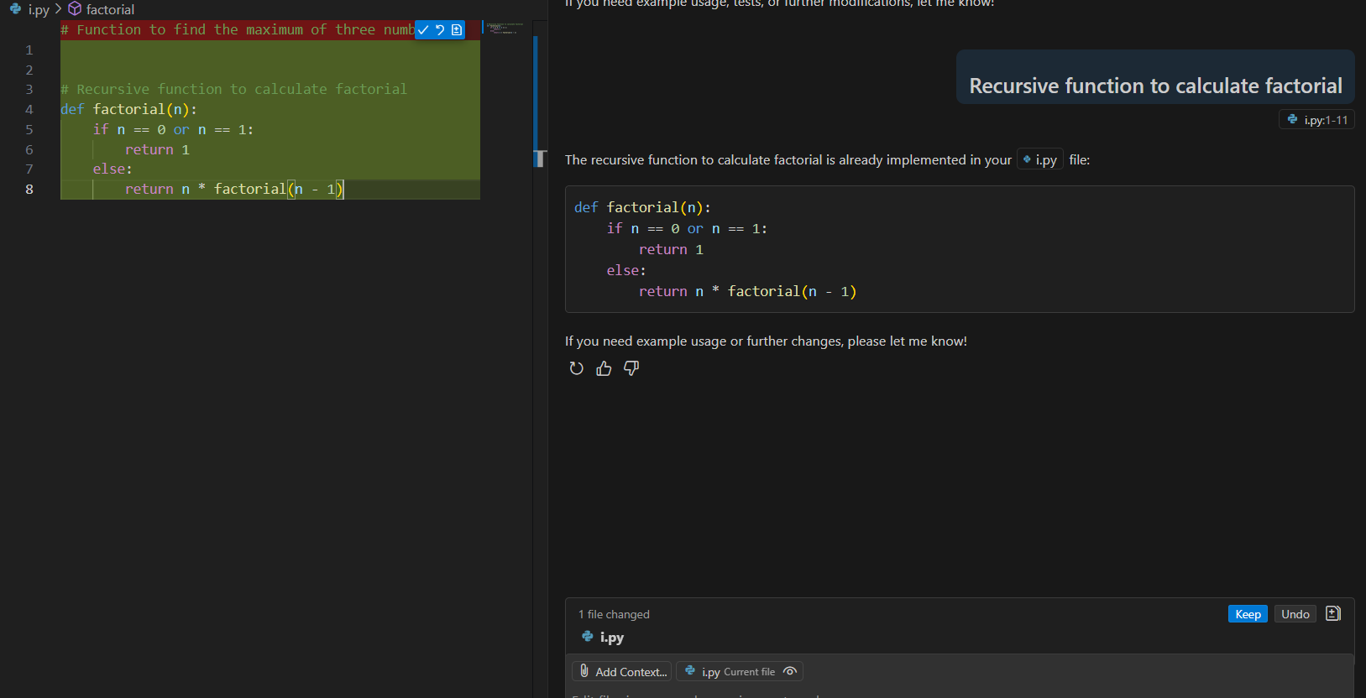

Explanation:  
The function calls itself recursively until n becomes 1 or 0, which is the base case.

Sample Output:  
Factorial of 5 is: 120

# Task 4: Student Class

Prompt used:  
# Define a class Student with name, roll_no, marks and display method

Code:

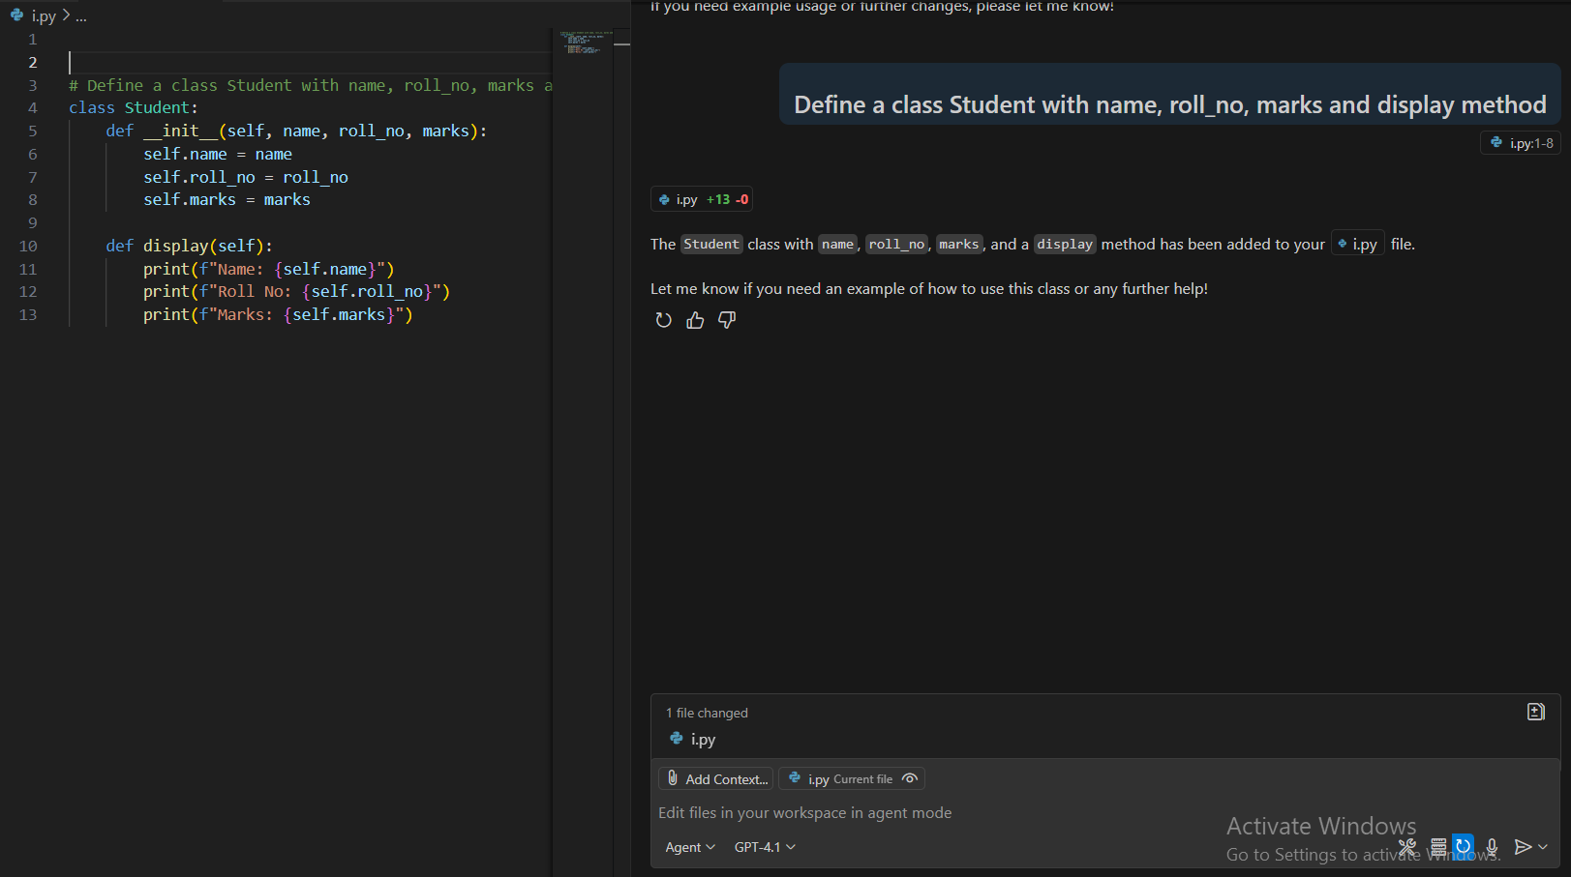

Explanation:  
This class defines a constructor (__init__) and a method display() to print the details of a student object.

Sample Output:  
Name: Aluwala Sharanya  
Roll No: 2403A52013  
Marks: 89

# Task 5: Word Frequency

Prompt used:  
# Function to return word frequency from a given string

Code:

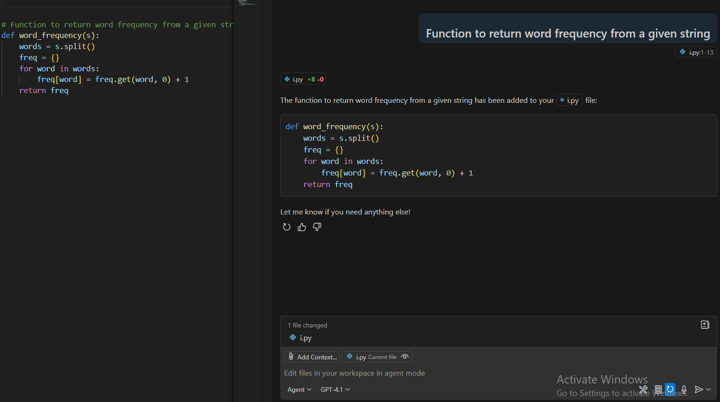

Explanation:  
The function splits the input string into words, converts them to lowercase, and uses a dictionary to count how many times each word appears.

Sample Output:  
{'ai': 2, 'makes': 1, 'coding': 2, 'easier': 1, 'is': 1, 'fun': 1, 'with': 1}